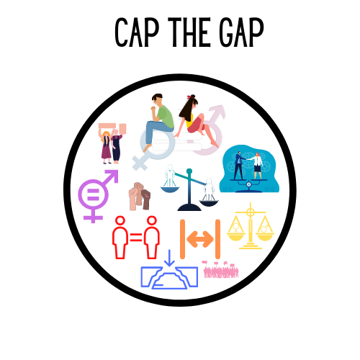

ESC Application Form
Thank you for your interest in the project Cap the Gap. We, the team of YEU Cyprus, want to get to know you better so please feel free to fill in the form below with short and to the point answers.
Personal Data
Name:
Surname:
Date of Birth
Email:
Gender: use (X) | M: |  | F: |  | Other:
Nationality:
Country of Residence:
Address:
City:
Postal Code:
Phone Number:
Occupation/Profession:

Do you have any health conditions, allergies, dietary or other special needs that the hosting organization should be aware of?
If yes, please explain.

These are characteristics for young people with fewer opportunities - please write ‘yes’ in the space provided if any of the categories apply to you.  (ESC is committed to support  inclusion for those who may  have faced difficulties) | Social Difficulties (facing discrimination because of gender/ethnicity/  religion/sexual orientation/disability, etc.; (ex)offenders, (ex)drug or  alcohol abusers, orphans, young people from broken families
Cultural Differences (ethnic minority; immigrants/ refugees or
descendants of them)
Economic Difficulties (low income, dependence on social welfare system,
unemployment or poverty, financial problems, homeless).
 | Disability (physical, sensory, mental, other)
 | Health Problems (chronic health problems, severe illnesses)
 | Geographical obstacles (Rural areas, islands, urban problem zones)
Educational difficulties (learning difficulties, school dropouts, lower
qualified, poor school performance)
If you answered ‘yes’ to any
of the above categories, please explain.

Motivation and Experience
1. Have you done any volunteering work in the past? (if yes, please tell us about it)

2. What, relevant to the project, education or work experience have you had? If you had none, then how do you associate yourself with this project?

3. Explain in your own words, why you believe that the gender gap remains a significant problem in modern society.

4. How do you see yourself contributing towards the achievement of eliminating the gap between genders?

5. Why are you interested in this project?

6. How can you contribute to the implementation of the project activities?

7. The activities in this project will require you to work in a team. How are your team working abilities?

8. How do you like the idea of interacting and working with people from different nationalities and cultures?

9. How did you find out about this ESC project?

10. What are your expectations and what do you hope to gain personally and professionally from your ESC experience? What would you like to learn?

11. What challenges do you think you will/might face during your ESC experience?

12. Have you ever lived away from home or abroad? Where and for how long? What was the experience like for you?

13. What might be your plans after you complete the ESC project, or what would you do if you are not selected for this project?

Personality Traits
Please select what you think describes you best  (write x where  applicable) | I am a leader
 | I am a follower
 | I listen to others first then I say my opinion
 | I only do what I believe is correct
 | I follow the rules even when I disagree with them
 | I impose my beliefs and opinions on others
 | I consider myself as a person who speaks a lot
 | I consider myself as a quiet person
 | I consider myself to be a team player
 | I can communicate with others easily
 | I have difficulties communicating with others
 | I consider myself to be a patient person
 | My mood changes fast
 | I am willing to try new things
 | I don’t like getting out of my comfort zone
 | I like to be helpful
 | I am passionate about gender inequality

Language Skills

Please write (x) according to your speaking and understanding level of English and any of the other languages. | Language level: | Basic | Intermediate | Advanced
 | English

Next Steps

Send this application together with your CV and Motivation Letter to evs@yeu-cyprus.org by the 28th of February 2022.
We will send you a confirmation email within 3 working days (confirming that we got your application) and timely inform you about the results of selection.
DISCLAIMER: In accordance with the EU’s General Data Protection Law, we as YEU Cyprus, hereby declare that the personal data submitted, are collected legally, fairly and in a transparent manner. Your data will be stored for 5 years from the date of your application. At the end of those 5 years all information will be deleted from our database.
THANK YOU for your interest!

