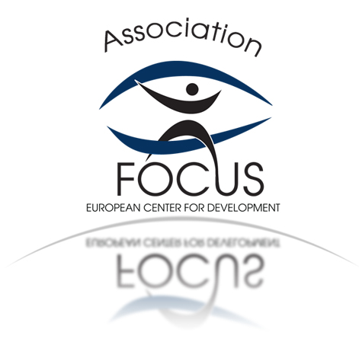

ACTIVITIES IN FOUR DIRECTIONS

Activity 1 –
Working with children with disabilities aged 6 to 18 at Day Care Center for Children with Disabilities. Organizing a variety of outdoor and indoor games, walking, painting, singing, dancing and cognitive therapy. Providing support in their everyday lives. Work therapy, sports and leisure related activities in the day care center for children with disabilities. Accompanying them while going to institutions and other establishments.
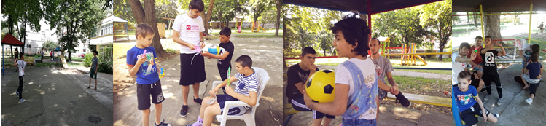

Activity 2 –
Working with young people with disabilities aged over 18 at Day Care Center for People with Disabilities. Help and support in orientation, walks in the park, visiting cafés, visiting a library and a museum. Art therapy, dance therapy, work-therapy. Drawing, application, making various works of various natural materials. Rationalization of leisure time and raising of skills and competences.
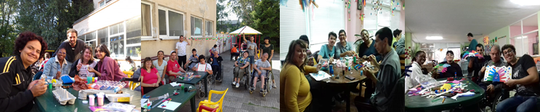

Activity 3 –
Working in the host organization. Website support, creating a newsletter and a project movie, creating presentations promoting the volunteer service, creating and maintaining a blog, developing and participating in projects such as youth exchanges, trainings and others.
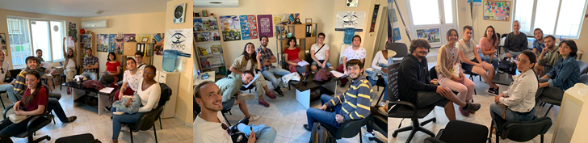

Activity 4 –
Working in elementary school and support for children aged 6 to 12. Rationalization of leisure time, organizing games and sports activities, assistance and support in learning and preparation of school lessons, building of soft skills and competencies. Games and jokes to increase motivation for learning.



