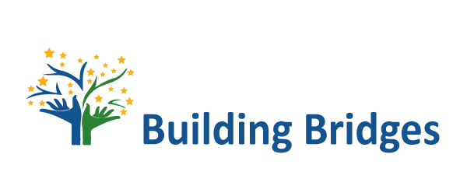

SENDING ORGANISATION DATA

ASOCIACIÓN CULTURAL BUILDING BRIDGES
Calle de la Cruzada 3 , 28013, Madrid
E-mail: asociacionbb@gmail.com

SERVICIO VOLUNTARIO INTERNACIONAL
INTERNATIONAL VOLUNTARY SERVICE

PHOTO
- Application Form -

CANDIDATE PERSONAL DATA

Name:

Surname:
Sex: F  M 

Date of birth:

Place of birth:
Nationality:
Skype contact:
Emergeny contact name, mobile phone and e-mail:

VOLUNTEERING PROGRAMMES LIST OF PREFERENCE

Preference order | COUNTRY | NAME OF PROJECT | DATES | CODE
1
2
3
4
5

EDUCATION AND OTHER TRAINING COURSES
Title of qualification awarded:

Training courses and masters, if any:

FOREIGN LANGUAGES
(Lenguas extranjeras)
Foreign languages and level of competence
[elementary (A1-A2) intermediate (B1-B2) advanced (C1), proficiency (C2)]:

CURRENT JOB

Please describe your current job:

SPECIAL MEDICAL NEEDS

Do you have any specific medical needs (chronic illnesses and specific medicines, allergies, food intolerance, disability, etc.)? Please give details and/or attach documentation to this application:

FURTHER CANDIDATES’ INFORMATION

Do you have a driving license? Yes  No 

What are your hobbies?

How would you describe yourself (values and weaknesses, roles of friends in your life, importance of school and job)?

Please, describe your previous experiences in other countries and your contacts with people of other nationalities and cultures:

INFORMATION ABOUT THE VOLUNTARY SERVICE

Describe your previous experiences as volunteer (describe also the movements, the organizations and programmes you worked with), if any:

Why would you like to take part in the European Voluntary Service (describe your expectations and what you think you may offer to the project)?

What would you like to learn from this project in terms of non-formal education?

What do you plan to do in order to exploit the results of your EVS project when you will go back home?

What are your plans for the future?

Have you ever taken part in any volunteer work? Where? When? For how long?

Which field of voluntary service would you like to work in? Why?

