APPLICATION FORM
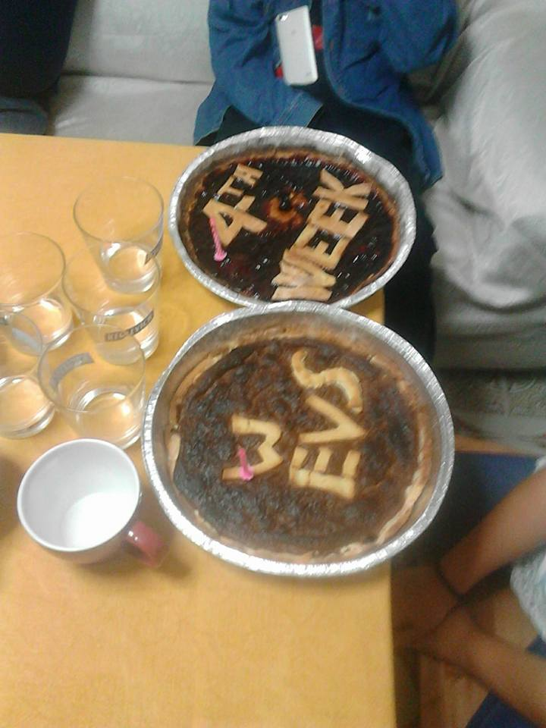 in the field of Non-formal learning for schools

Thank you for your interest in our project. We would like to understand better your motivation in taking part in this specific project. So please, read carefully the form, answer the questions (in English or Italian) and do not forget to ask your sending organization to send the form together with your CV with picture.
Ti ringraziamo per l’interesse che hai per i nostri progetti. Vogliamo capire meglio la tua motivazione a prendere parte a questo specifico progetto. Quindi, per favore, leggi attentamente il formulario, rispondi alle domande (in italiano o in inglese) e non dimenticarti di chiedere alla tua organizzazione di invio di inviare il formulario assieme al tuo CV con foto.

1. YOUR MOTIVATION. LA TUA MOTIVAZIONE.
1.1 Where would you like to do your voluntary service (if you want to apply for more than one organization please use another application form)? Dove vuoi svolgere il tuo servizio di volontariato (se vuoi candidarti per più di un'organizzazione, devi compilare un altro modulo)?
1) Scuola Media “Battisti Ferraris” - Bisceglie
2) ITET - Molfetta

1.2. Description of the project. Descrizione del progetto.
Please, describe, using your own words, how you imagine a typical day will be like in your receiving organization. Per favore, descrivi a parole tue, come immagini una giornata tipo presso il tuo ente di accoglienza.

1.3.Your motivation La tua motivazione
Please describe below carefully your motivation for this specific project. Per favore, descrivi accuratamente di seguito la tua motivazione per questo progetto specifico.

1.4. Knowledge and skills you can share during your EVS experience. Conoscenze e competenze che potresti condividere durante la tua esperienza di SVE.

1.5. Knowledge and skills you hope to gain during your EVS experience. Conoscenze e competenze che speri di ottenere durante la tua esperienza di SVE.

1.6. Which challenges do you think you will encounter during your stay abroad? Quali sfide pensi di dover affrontare durante la tua permanenza all'estero?

1.7. Please indicate at least 3 of your strengths and do not forget to illustrate them giving an example. Per favore, indica almeno 3 dei tuoi punti di forza e non dimenticare di illustrarli attraverso esempi.

1.8. Please indicate at least 3 of your weaknesses and do not forget to illustrate them giving an example. Per favore, indica almeno 3 dei tuoi punti di debolezza e non dimenticarti di illustrarli attraverso esempi.

1.9. Please, indicate some activities you do not like to do. Per favore, indica delle attività che non ti piace fare.

1.10. Is there anything else you would like to tell? C'è qualcos'altro che vorresti aggiungere?

2. PLEASE FILL IN THE FOLLOWING DETAILS FOR YOUR APPLICATION!

PER FAVORE INSERISCI I SEGUENTI DATI PER LA TUA CANDIDATURA!

2.1. Personal information. Informazioni personali.

Name  Nome |  | Surname  Cognome
Indirizzo  Address |  | Città e CAP  City and Postcode

Gender  Genere |  | Nationality  Cittadinanza
Date of birth  Data di nascita |  | Place of birth  Luogo di nascita
Passport (ID) Number
Numero di passaporto
Person to contact in case of emergency (Name, Address, Telephone and Email). Persona da contattare in caso di emergenza (nome, indirizzo, telefono, email).

2.2. Special needs. Bisogni specifici.
Do you have any special needs (medical conditions, handicaps, etc.)? Hai bisogni specifici (condizioni mediche, handicap, etc.)? | Yes __ | No __
Do you have any kind of allergy? Hai qualche allergia? | Yes __ | No __
Do you need to take any kind of medicine? Devi prendere qualche medicina? | Yes __ | No __
Is there any food you do not eat? C'è del cibo che non mangi? | Yes __ | No __

2.3. Please give further description if you have answered “YES” to any of the above questions. Per favore, daI una descrizione più dettagliata per i campi dove hai segnato “YES”.

Declaration
I declare that all of the information on this application form is honest and truthful to ability, experience and support needs and has been completed by the volunteer named on this application.

Please tick here to show you understand and accept the above declaration
Do not forget to send together with this form your CV with picture!

Thank you for filling in the application form! The next page is for your sending organisation.
Grazie per aver compilato il formulario di candidatura! La pagina successiva è per la tua organizzazione di invio.
Please note that we can only accept your application if you indicate your sending organization and attach your CV with picture!
Per favore, nota che accetteremo la candidatura solo se indichi l'organizzazione di invio e alleghi il tuo CV con foto!

3. FOR YOUR SENDING ORGANIZATION

PARTNER IDENTIFICATION FORM
PARTNER PROFILE
PIC | 948341162
Promoter’s legal name (national language) | Ապագան մեր ձեռքերում
Promoter’s legal name (latin characters) | Future in Our Hands
Acronym, if applicable | FIOH
National ID number, if applicable
Department if applicable
EVS Accreditation Number -EI Ref | 2015-1-PL01-KA110-017831
Legal address | Tartu 2/31
Postal code | 2202
City | Abovyan
Country | Armenia
Region | Kotayk
Web site | www.fioh-ngo.com
Email | info@fioh-ngo.com
Telephone | +37495337873
Person authorised to legally commit the promoter (legal respresentative)
Title | Mr.
Family name | Aleksanyan
First name | Albert
Position | President
Email | Infofuture11@gmail.com
Telephone 1 | +37495337873
Telephone 2
Same address as the organisation (if address is the same as the one of the organisation please tick this box, otherwise please use the box below to input the full address
Same Address

Person responsible for the implementation of the action (contact person)
Title | Ms
Family name | Aleksanyan
First name | Tigranuhi
Position | Director/Coordinator
Email | tigranuhialeksanyan@gmail.com
Telephone 1 | +995550001806
Telephone 2
Same address as the organisation (if address is the same as the one of the organisation please tick this box, otherwise please use the box below to input the full address

TYPE OF ORGANISATION (please respond YES or NO to the following questions)
Is your organisation a public body? | NGO
Is your organisation a private entity? | Private
Is your organisation a non-profit?: | non profit
Is your organisation: a public body at regional/national level; an association of regions; a European Grouping of Territorial Cooperation; or a profit-making body active in Corporate Social Responsibility?- | International

ACCREDITATION (Has the organization received any type of accreditation before submitting this application?)
Accreditation Reference (EVS) | 2015-1-PL01-KA110-017831 Sending
Any other type of accreditation relevant to the application for this project

BACKGROUND AND EXPERIENCE
Please briefly present your organization
“Future in Our Hands ” Youth non-governmenal organization’s general idea is to carry outsocially useful activity. The members of the organization are mostly youth (students,
high school pupils,etc…) and specialist of working with youth and children, united around
the idea of promoting education and European awarness among the youth and generally
among the society, supporting people, helping people with fewer opportunities in their
social integration, making youth participation in public life more active and strengthening
the principles of civil society and democracy. The main objectives of the organization are:

• Implement a number of studies and joint training to assist local authorities on matters of
public interest;
• To develop solidarity and promote tolerance among the public
• To encourage public participation and strengthening links between local groups, schools, businesses and municipal authorities.
• To stimulate participation of young people for involvement in activities related to personal and social development activities for social adaptation of marginalized youth communities.
• To carry out active work for sustainable social development and democratic principles to
promote civil society.
• To work for action and measures to restore and improve the quality of the environment.
• To improve the welfare of disabled people – their acceptance and finding a place in a family in a circle of peers, colleagues, friends and the m iddle part of the community in which they live.
• Ensure including accepting and encouraging environment for children and youth with disabilities.
• To counteract negative social phenomena, spreading in a youth environment, such as: crime, aggression, addiction, prostitution, xenophobia and others.
What are the activities and experience of your organisation in the areas relevant for this application?

Future in Our Hands is a young organization activities are mostly based on non-formal methods. We organize different kind of seminars, trainings, exchanges, summer camps, etc.. full of games and energizers…We use this non formal method while our activities, which makes the learning process easier and much more interesting to the youth.
We work in different topics, involving different youth with different backgrounds, as we do believe that we need developed youth for our future development. Here is why we have different specialists working in different target group youth.
The members of the organization have had a chance to take part in different international projects and to get different types of working methods.
Recently we have hosted a youth exchange in Armenia “Tram of Art”, which was about art and photography, which brought together 50 youth from different cultural backgrounds to create their own exhibition in the center of Yerevan.
At the same time we took part in different international activities, such as: “Nature, Culture, Creativity” for teenagers with fewer opportunities from 16-19y.o.
“Let’s Learn Tech” in Italy, which was about IT skills development, how secure to use internet and social network. Many other exchanges, training courses for our youth in CZ, Ukraine, Turkey, UK, Moldova, Georgia in topics such as: recycling, against prejudice, IT skills, art, culture, entrepreneurship, business development, leadership, etc. At the same time we had different Partner building activities in order to widen our partner network to create more possibilities for our youth.

What are the skills and expertise of key staff/persons involved in this application?

-General organizational skills
-Planning, scheduling skills
-Meeting Deadlines and Time Management
-Coordinating resources
-project writing/hosting skills
All the activities that are planned to be relalized by the NGO “Future in Our Hands” could not be achieved without a team of specialists, members of the organization-students, teachers, social workers, physiologies, educators, computer specialists, graphic designers, parents, public. All together: that is Public, Society, is the main team of the NGO “Future in Our Hands”.
But the main mobility organization activities will be realized by Tigranuhi Aleksanyan, Albert Aleksanyan, Ani Voskanyan, Ani Aghababyan.
Albert Aleksanyan is the president of the NGO. Albert has studied at Moscow Electronical Institute, in the faculty of Radio Engineering. From 1996 he is working at Getamej primary school. He has 20 years experience in working with children at school, in event organization, holiday, weekend stay organization, administrative tasks of the school. He has also an experience of taking part in Youth in Action programs such as: PBA’s and youth exchanges as a leader.

Ani Voskanyan is the youth worker of the NGO. he has graduated from European Educational Regional Academy ( ERIICTA). In the faculty of International relations. She large experience in working with youth , helping them in their social integration, in the participation of different projects, she has been a short term EVS volunteer in Turkey, Bodrum. Also she has taken part in different international and local trainings in Poland, Spain, Georgia, Armenia, etc so the multicultural background of hers helps her in her successful activities.

Tigranuhi Aleksanyan is co-Founder of the NGO , as well as coordinator of International projects. She has Graduated Yerevan State Linguistic University after V. Brusov, faculty of Linguistics and Intercultural Communication, specialization English-International Tourism. She has done a short and another long term EVS in Bulgaria and Czech Republic. She has wide international experience, both as a participant and as a facilitator. She has facilitated a project in Czech Republic when being an EVS volunteer, then a few projects in Armenia. She has also experience in project management, project writing, realizing and analyzing.

Ani Aghababyan is the volunteers’ coordinator. She is still a student in Yerevan State Linguistic University after V. Brusov., faculty of Linguistics and Intercultural Communication. Specialization English-International Tourism. She is also an ex EVS volunteer. She had her international experience from June to September, where her activities were involving learning how to coordinate and write projects. So she is using her skills gained abroad when working with our youth.
We would also like to mention that we are cooperating with ex EVS volunteers in Armenia, we have good contacts with them and from time to time we're organizing different events with each other.
Also we have psychologists and teachers in our team that work with our target group.

About your volunteer (if already identified)
> Brief description of your volunteer

> Participants with Fewer Opportunities? Please specify
Budget
> Using the distance calculator of EU, please inform us the total Km and budget requested for travel (http://ec.europa.eu/programmes/erasmus-plus/tools/distance_en.htm):
….......... Km ….......... €

> Budget requested for visa/vaccination costs (if applicable):

